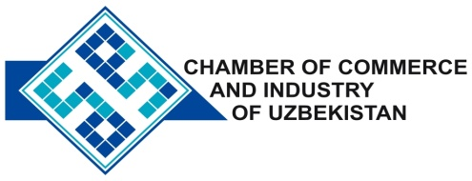

**Commercial offer of Uzbek Products to Foreign Buyer**

Dear Sirs, №PSM-004

We offer quotation of Uzbek companies Ltd« Savdo Industrial Group »

**Information about the company:**

Company LLC «Savdo Industrial Group» was founded in 2008. The company specializes in the production of door and window rubber seals and metal reinforcement, and remote frames.

**List of products:**

Production of door, window rubber seals and metal reinforcement spacer.

**Benefits:**

Ease of handling and installation, superior performance for thermal and acoustic insulation.

**Terms of delivery:** FCA Tashkent

If you are interested, we are happy to provide additional information in accordance with your request.

E-mail: [export@chamber.uz](mailto:export@chamber.uz)

Website: [www.chamber.uz](http://www.chamber.uz)

Export Promotion Department.

Chamber of Commerce of the Republic of Uzbekistan.